Homeostasis Assignment

Homeostasis
For the following homeostatic mechanism, identify the various parts.

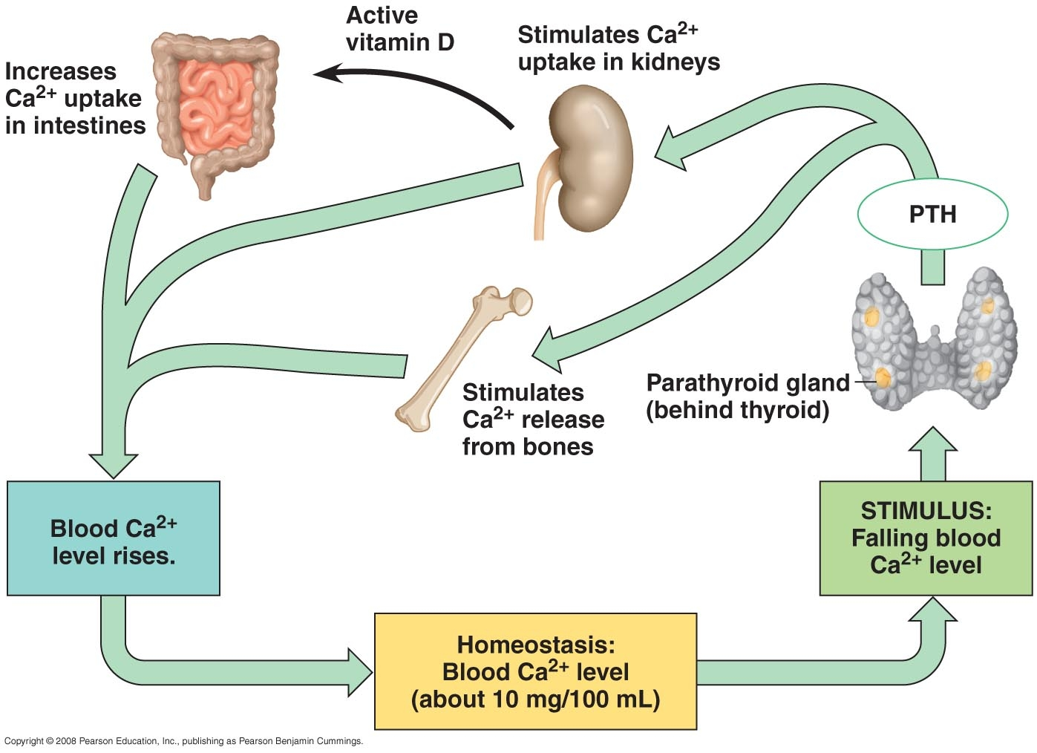

Set Point
Stimulus
Receptor
Integration Center
Effector
Response
Negative or Positive Feedback
For the following control mechanism, identify the various parts.

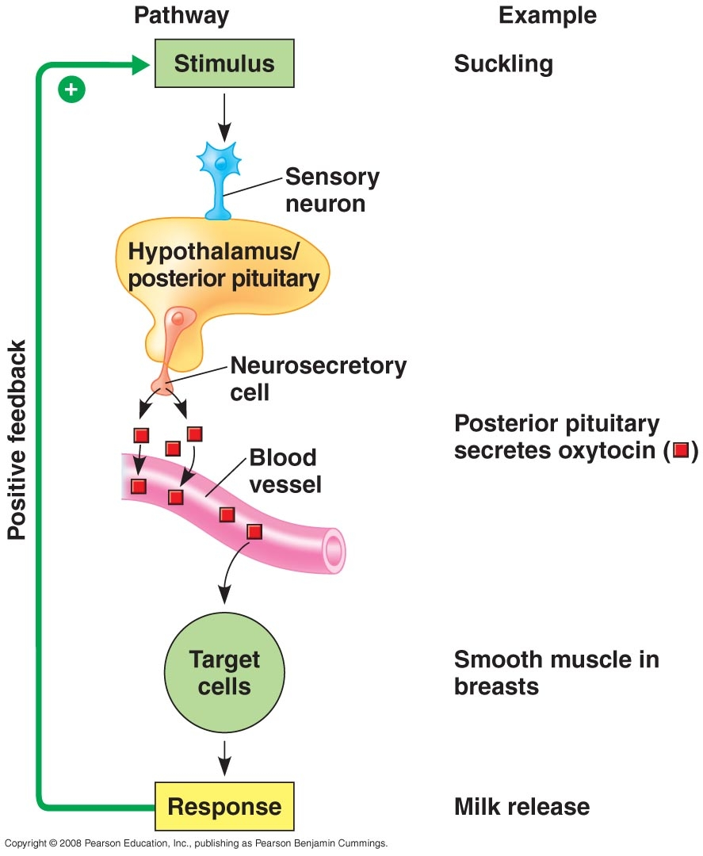
Suckling
Smooth muscle in breast
Milk Release

Set Point | Not Applicable
Stimulus
Receptor
Integration Center
Effector
Response
Negative or Positive Feedback
Comparison
Compare mechanisms of water balance in the following organisms.

Organism | Mechanism of Water Balance
Bacteria
Paramecium
Fungus
Typical Plant
Cactus
Tardigrades (pages 956-957)
Jellyfish
Marine Bony Fish
Freshwater Fish
Sharks (page 956)
Albatross, a marine bird
with salt glands
Kangaroo Rat (page 957)
Zebra, a typical mammal

Further Explorations

Water Balance in Desert Plants
Go here: http://www.desertusa.com/du_plantsurv.html

1. What are xerophytes and what conditions are they adapted for?
2. What are the adaptations of cacti to desert life? Explain how those adaptations
help them survive desert conditions.
3. What are phreatophytes? Explain how they are adapted to desert life.
4. Discuss the adaptations of the perennial Ocotillo plant to desert life.
5. Discuss the adaptations of ephemeral plants to desert life.
6. Describe the seed bank of the Sonoran Desert.

Desert Potholes
Go here: http://nai.arc.nasa.gov/news_stories/news_detail.cfm?ID=19

1. What is anhydrobiosis?
2. How do anhydrotiotic nematodes survive without water?
3. Discuss two other adaptive strategies seen in desert pothole animals.
4. Discuss the adaptations of brine shrimp to ephemeral habitats, such as desert
potholes.

Life's Too Short Not to Know About Tardigrades!
Go here: http://www.tardigrades.com/
Click on "Water Bears".
Then, click on "Tardigrades: The Video".

